**OUTPUT SCREENSHOTS**

**CODING SCREENSHOT:**

**UserAuthentication.java**

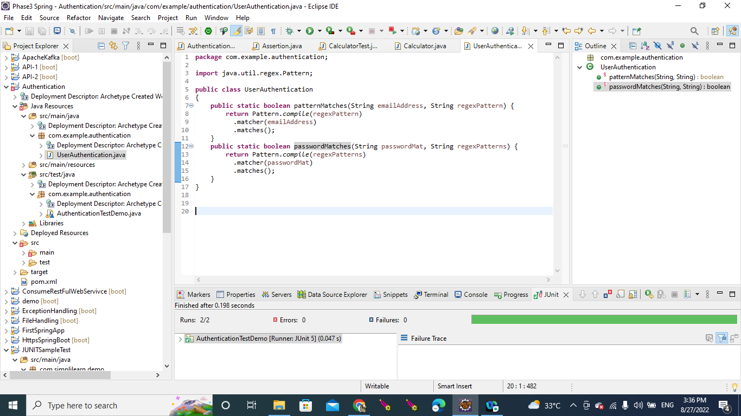

**AuthenticationTestDemo.java (Junit)**

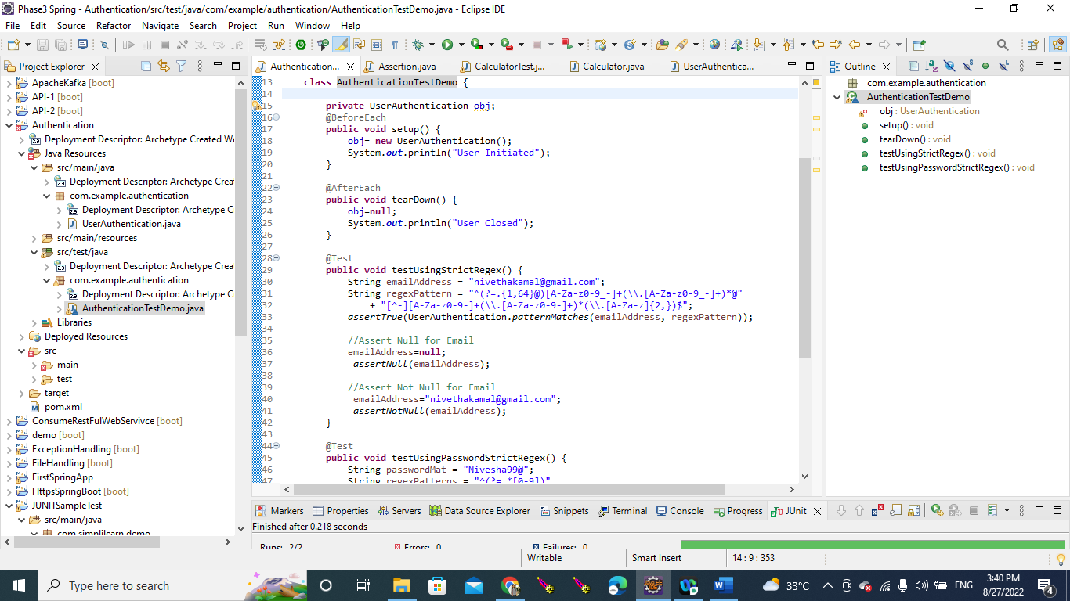

**OUTPUT SCREENSHOT:**

**Console Window:**

**JUNIT OUTPUT:**

